MINI PROJECT: COURSE FEEDBACK FORM
1. Introduction
This mini project involved developing a simple Course Feedback Form using Python and Streamlit. The purpose of the application is to collect structured feedback from students about their learning experience. The form allows students to provide their name, identify topics they understand, rate the module, and give written feedback about their journey.
2. Objectives
The main objectives were to:
- Create a feedback form using Streamlit.
- Collect the student's name.
- Allow students to select topics they understand.
- Obtain a module rating from 1 to 5.
- Collect written feedback.
- Display the submitted information in a formatted summary.
3. Implementation
The application begins by importing the Streamlit library:
import streamlit as st
A Streamlit form is then created using st.form("settings_form"). Using a form allows the different inputs to be collected before the user submits them.
The first input is a text field that collects the student's name:
student_name = st.text_input("Enter your name")
A multiselect widget is used to allow students to choose the topics they have a clear understanding of. The available topics are Deep Learning, Machine Learning, and LLMs.
The module rating is collected using a slider ranging from 1 to 5, with an initial value of 2:
module_rating = st.slider("Module Rating", 1, 5, 2)
A text area is also provided for the student to describe their learning journey and provide feedback.
4. Form Submission
The form contains a submit button labelled SUBMIT:
submit = st.form_submit_button("SUBMIT")
When the button is pressed, the program checks whether the form has been submitted. If it has, st.markdown() is used to display a summary containing the student's name, selected topics, module rating, and feedback.
The resulting output combines all the information into a single formatted statement, making it easy to view the student's complete response. 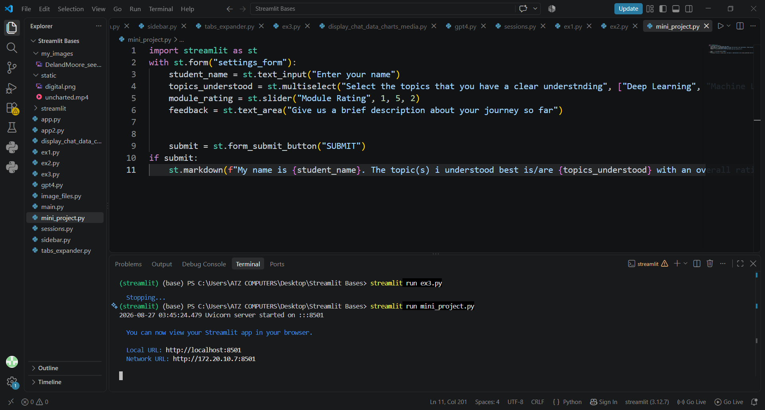
5. Results
The completed application provides a simple and organised feedback interface. The user can enter their name, select one or more topics, provide a module rating, write feedback, and submit the form.
The screenshot shows the Course Feedback Form exercise and its requirements, while the submitted Python implementation contains the corresponding Streamlit form components.
Figure 1: Course Feedback Form interface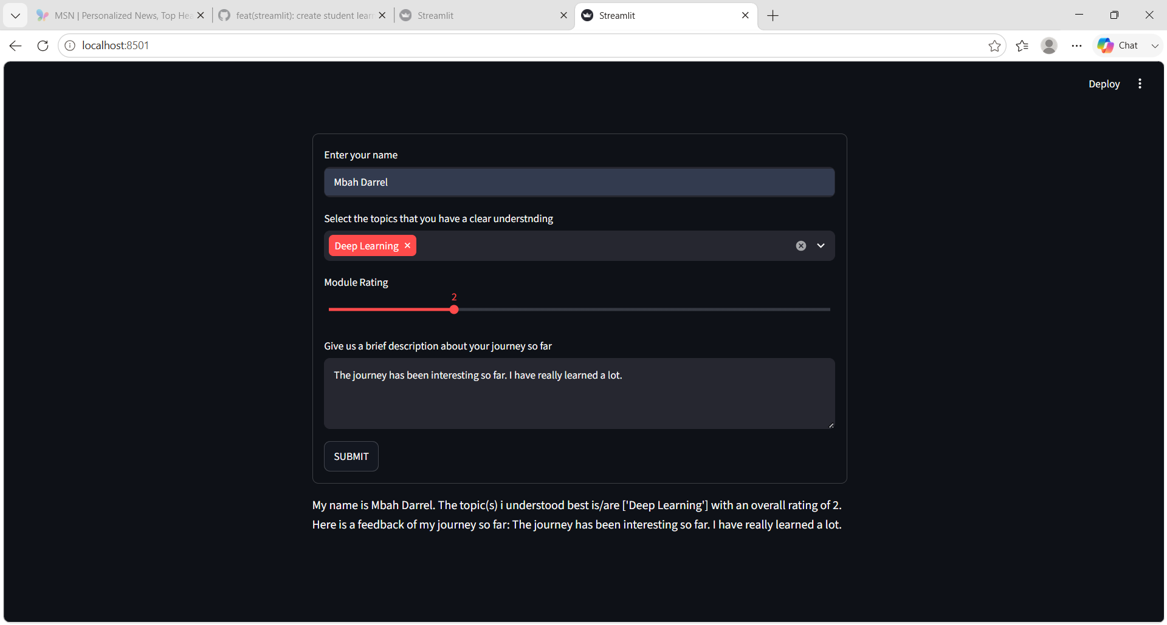
6. Conclusion
The mini project successfully demonstrates how Streamlit can be used to create an interactive feedback application. The project makes use of several Streamlit components, including forms, text inputs, multiselect widgets, sliders, text areas, and a submit button. It also demonstrates how the collected inputs can be combined and displayed as a summary after submission.
Overall, the exercise provided practical experience in building a structured user-input application with Python and Streamlit.

